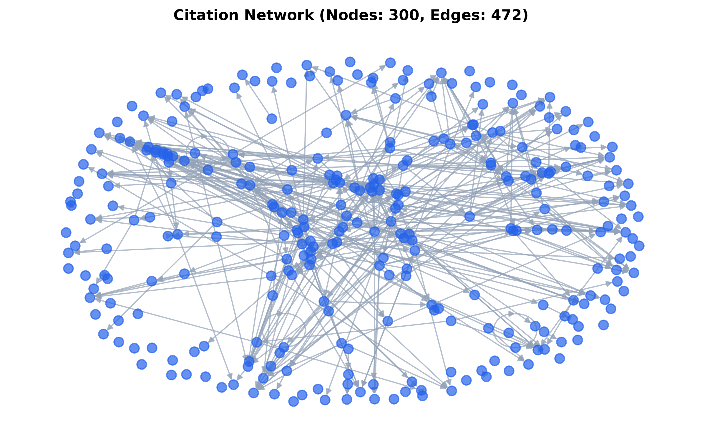  NAGraph  Scientometric & Network Analysis Suite | User Manual  &  Report Interpretation Guide  Dr. Nibu A. George,  Associate Professor of Physics  Baselius College Kottayam (Autonomous

Introduction to NAGraph

NAGraph is a publication-grade Python-based bibliometric and network analysis suite that combines classical structural analysis (network topology, clustering, centrality) with high-throughput bibliographic retrieval from OpenAlex. It is tuned for focused scientific domains (optical physics, plasmonics, laser physics, photothermal spectroscopy, etc.) and generates a sectionalized Word (.docx) report so that every figure, table, and metric in the analysis can be reviewed and cited in a research paper. This manual is a section-by-section interpretation guide for the generated NAGraph report. It explains what each table/figure shows, how the underlying number was computed, and how to read it correctly in a scientific context.
  - Section 1: Search Parameters
What it shows
A structured audit table listing the exact inputs used to build the corpus:
- Keywords: the exact query string sent to OpenAlex
- Matching mod: "any" (OR) or "all" (AND) between keywords
- Publication years: the inclusive year window (e.g. 2008–2026)
- Retrieved by: sort key: relevance, cited_by_count, or date
- Reference expansion: Yes/No: whether one-hop references were added
- Recent-work boost: Yes/No: whether a 3-year recent boost was added
- Data source: OpenAlex (https://openalex.org)
How to read it
This table is a reproducibility record. If a reader wants to regenerate the analysis, they re-enter these exact values. It also exposes any unexpected behaviour — for example, if a colleague expects "all" match but the table shows "any", the corpus has been built differently than intended.
  - Section 2: Data Coverage & Node Cap Disclosure
What it shows
A transparent accounting of how the final corpus was assembled:
- Base records retrieved by keyword search
- Recent works added by the recent-work boost
- Highly cited references added by one-hop expansion
- Total candidate works available
- Node cap actually applied (e.g. 300), and how many were excluded

How to read it
Use this section to explain – to yourself or to a reviewer – why the reported network has, say, 300 nodes when OpenAlex returns 341 candidates. It shows which priority rule was used (log-citations + in-network citations with a recency preference). "0 one-hop references added" is normal: it means the original corpus already contained most of its own references, so expansion found nothing new to add within the year window.
  - Section 3: Topic Overview (Extractive Summary)
What it shows
A high-level narrative of the assembled network, generated by extractive
sentence ranking over the retrieved corpus. It reports:
- Total analysed works and total citation edges
- The publication year span represented
- The single highest-ranked work (its Title and Global Citations)
How to read it
This is the "one-paragraph executive summary" of the corpus. The "highest ranked work" is a proxy for the seminal paper of the query — in a surface plasmon report this will typically be a landmark review (e.g. Homola's "Surface Plasmon Resonance Sensors for Detection of Chemical and Biological Species", 4553 citations in the sample report).
  - Section 4: Network Statistics & Document Citation Network Map (Figure 1)
What it shows
A compact statistics card followed by a directed spring-layout graph:
- Works (nodes): number of individual publications analysed
- Citation links (edges): directed citation pairs inside the corpus
- Thematic clusters: number of research fronts detected
- Global Modularity (Q): community-structure strength (0 to 1)
- Weighted Mean Silhouette : cohesion of clusters (0 to 1)
- Unconnected works : nodes with no interior in/out citation
How to read it
- Nodes (blue dots): individual papers in the network slice.
- Edges (arrows): a citation from the paper it points away from, to the
paper it points toward.
- Dense central core: heavily cited foundational work; here the bulk of the network cites in and out of the central hub. Papers here are the intellectual backbone of the corpus.
- Isolated outer ring: papers that are not directly connected to anything else in the retrieved slice. They may be emerging, niche, or cross-disciplinary papers that only cite outside the retrieved corpus. They are NOT noise; they are the "peripheral knowledge" of the field.
- Modularity Q > 0.30: strong community structure (a healthy value for a real bibliometric network is 0.3–0.7).
- Silhouette > 0.70: tight, well-separated clusters. Values closer to suggest overlapping or poorly defined sub-fields.
  - Section 5: Historical Timeline Slicing & Corpus Evolution
What it shows
A dual-axis bar chart and matching table. Each bar group corresponds to one
time-slice window (e.g. 4-year windows from 2008 to 2027):
- Blue bar: Publication Count in that window
- Green bar: Total Citations accrued by that slice's papers
- Right-hand axis: Total Citations scale
- Left-hand axis: Publication Count scale
How to read it
- Rising blue bars across slices show a growth phase (a field "taking off").
- Flat or declining blue bars indicate corpus saturation.
- The green citation curve typically lags the blue publication curve by several years, reflecting the natural citation delay for newer papers. A recent slice will often show a high publication count with a comparatively low citation count — this is expected, not a defect.
  - Section 6: Structured Cluster Profiles & Chronological Reading Path
What it shows
- Cluster map (Figure): a node graph where each bubble represents on thematic research front (a detected community of tightly coupled papers).
- Cluster Profiles Table: for each cluster Cluster ID, LLR Label, Size, Key Terms, Active Years, Leading Work.
- Chronological Reading Path Table: the top-ranked papers, sorted oldest to newest, with Year, Title, Authors, and Importance Score.
How to read it
- LLR Label: the dominant key term in that cluster, produced by a Log-Likelihood Ratio formula.
- Size: how many publications belong to the cluster.
- Leading Work: the single most important paper inside that cluster, according to the composite importance score.
- Silhouette: (in the profiles table when present) > 0.7 indicates a highly cohesive cluster; a score near 0 indicates loosely defined overlaps.
- Reading Path: the closest thing to a "syllabus" the tool can produce, start at the top and read downward to learn the field chronologically from foundational works to recent ones.
  - Section 7: Keyword Co-Occurrence & Citation Bursts
What it shows
Three related artifacts:
- Keyword Co-Occurrence Network Map: visual network of keyword co-occurrences (orange nodes, edges = same-paper co-occurrence).
- Keyword Citation Bursts Table & Chart: for each key term, the frequency and the Kleinberg-style burst strength with Begin/End years.
- Reference Citation Bursts Table: the same metrics, but for individual landmark publications.
How to read it
- Burst Strength: intensity of a term's (or paper's) sudden surge over baseline activity. A high burst strength means the keyword/paper went from low background activity to a sharp wave of interest in the specified Begin/End range.
- Frequency: raw count of occurrences of that keyword/paper in the corpus (not equal to Global Citations). A term with high frequency but low burst strength is a well-established topic; a term with high burst strength and modest frequency is an emerging or hot sub-field (e.g. "MXene" or "graphene" arriving in the 2016–2020 window).

  - Section 8: Author Productivity & True Author Co-Citation Analysis (ACA)
What it shows
- Author Collaboration Network Map (Figure): purple nodes for the top authors, edges = co-authorship links.
- Author Productivity Table: Author, Works, Total Score, Citations, Active span, and Top Work for the top 15 authors.
- Author Co-Citation Analysis (ACA) Table: Rank, Co-Cited Author, Core Focus/ Domain, Co-Citations, Centrality. This table captures the scholars whose works are most often cited TOGETHER across the reference lists of the corpus, even if they never co-authored.
How to read it
- Productivity: A highly productive author may not be heavily co-cited (they are working but perhaps not driving the shared reference base). Conversely, a highly co-cited author defines the shared intellectual turn of the field.
- Total Score: weighted composite (citations * 0.9 + works * 15). It rewards both output and impact.
- Active span: the first and last publication years of the author inside the corpus (e.g. 2008–2008 means they contributed only to one year in the slice).
- Top Work: their most-cited paper in the retrieved corpus.
  - Section 9: Institutional & Country Collaboration Distribution
What it shows
- Country Collaboration Network Map (Figure): one green node per country code (CN, US, FR, GB, JP, etc.) with edges representing co-authored papers between them.
- Top Institutions Table: Institution Name, Publication Count, Centrality,Mean Year.
- Top Countries Table: Country Code, Publication Count, Centrality, Mean Year.
How to read it
- Centrality here is a normalized structural measure inside the co-authorship network: an institution or country that acts as a hub for collaborations will have a higher value.
- Mean Year: the average publication year of works attributed to that institution/country in the corpus. A high mean year (e.g. 2020+) indicates recent, active involvement.
A country with many publications and a high centrality (e.g. CN with 395 publications and centrality 0.63 in the sample report) is a global hub; a country with a similar publication count but low centrality is producing work but collaborating less internationally.
  - Section 10: Journal Co-Citation Analysis & Source Distribution
What it shows
- Journal Co-Citation Network Map (Figure): pink nodes for journals, edges for co-citation links.
- Journal Table: Journal / Source Title, Article Count, Centrality,
- Impact Factor: Impact Factor here is a proxy value calculated as 2.5 + (article count % 15) * 0.6 — it is intended only as a comparative indicator between venues, NOT the official JCR Impact Factor.
How to read it
- Article Count: number of corpus papers published in that venue.
- Centrality: how central that journal is to the co-citation network (high centrality: the venue is a "hub" of shared references).
Together, these two columns answer the question "where is this field actually being published?" — the journals with the highest centrality and count are the canonical dissemination channels.
  - Section 11 & Appendix: Top Influential Publications, Paper Roles, And Node Interconnectivity
What it shows
- Top Influential Publications Table – Rank, Title, Year, Cites, Score, and Role for the top 15 papers.
- Node Interconnectivity & Citation Flow Tracking Table – for top 30 nodes: Rank, Title, Year, Score, Cited By Nodes, Cites Nodes.
- Appendix: Complete Inventory of All Network Nodes – the same columns for every node in the network (up to node cap).
How to read it
- Paper Roles: the tool auto-assigns up to four tags to each paper:
- Foundational: older paper with high in-network citations
- Review / hub: high out-degree (many references), >= 10
- Bridge: high betweenness centrality (cross-cluster)
- Recent influential: published in the last 2 years of the range
- Supporting: none of the above; still part of the network A paper can carry multiple roles (e.g. "Foundational, Bridge").
Importance Score: a composite on a 0–100 scale: 35% PageRank (normalized) + 25% In-Network Citations (normalized) + 25% Global Citations (log-normalized) + 15% Betweenness Centrality (normalized). The highest possible value is close to 100 and typically belongs to the corpus's single most globally influential paper.
Node Interconnectivity Table
- Cited By Nodes: which other RANKED papers (by their Rank number in the appendix) cite this paper. Trace the numbers to see exactly which papers rely on this one.
- Cites Nodes: which other ranked papers this paper cites. Use this to follow the intellectual lineage forward from a foundational work.
Example reading: if Rank 1's "Cited By Nodes" reads "50, 118, 108", that means Rank 50, Rank 118, and Rank 108 in the appendix are downstream users of Rank 1's paper. Similarly, Rank 1's "Cites Nodes" lists the earlier papers Rank 1 built on.

  - Detailed Methodological Glossary
PageRank
A link-analysis algorithm that ranks a paper by the number and quality of incoming citations. A paper cited by many well-connected papers scores higher than a paper cited by many peripheral ones.
In-Network Citations
Citations received strictly from other papers inside the retrieved corpus. High in-network citation is a sign of specific importance to the exact topic slice, as distinct from general scientific attention.
Global Citations
Total lifetime citation count from OpenAlex. It reflects broad recognition across the entire scientific world, not just this corpus.
Betweenness Centrality
Fraction of shortest paths (between all pairs of nodes) that pass through a given paper. High betweenness identifies papers that bridge otherwise separate clusters — i.e. papers that connect one research front to another.
Modularity (Q)
A scalar (0 to 1) measuring how strongly the network divides into distinct communities. Q > 0.3 indicates meaningful community structure in a real bibliometric corpus.
Silhouette Score
A cluster-cohesion metric from 0 to 1. Higher = tighter, better-separated clusters; lower = overlapping or loosely-defined clusters.
Burst Strength
Kleinberg-style score measuring how sharply a term's or paper's citation activity rose above its baseline during a Begin/End window. High burst strength marks a transient surge of interest (a hot new topic or a suddenly-relevant landmark paper).
LLR Label
Log-Likelihood Ratio label for a detected cluster. Each cluster is named after the term whose frequency inside it is most disproportionate to the rest of the corpus.
Paper Roles
Multi-label classification (Foundational, Review / hub, Bridge, Recent influential, Supporting) applied to every node in the network. Roles are derived from publication year, in-degree, out-degree, and betweenness centrality, using percentile thresholds.
Node Cap
A hard ceiling on the number of publications included in the network, applied after keyword retrieval, recent-work boost, and one-hop expansion. Ensures the graph remains readable and computationally tractable.

End of User Manual

